MS Interactive Workshop for Year 1 Occupational Therapy Students
Facilitators: Beth Cooke – OT and BU’s PIER partnership

Aims of the Session
To create an active learning environment for Occupational Therapy students to explore the condition of Multiple Sclerosis (MS). The Workshop is set up to allow students to explore the condition through means of direct discussion in small groups with people who have a condition of MS or live with someone who does. The aim is to increase knowledge of the condition, gain an insight into how the condition may be managed, how it affects individuals, establish an understanding of the need for self-management, and to enable students to ask questions in a non-threatening situation.
Learning Outcomes for OT students
- Improve awareness of managing MS as a long term condition.
- Talk about fatigue management, pacing, use of diaries to manage fatigue.
- Improve awareness of positive risk taking.
- Consider impact of specialist equipment on independence.
- Gain insight and learning points for students to then take into practice.
- Consider the role of the Occupational Therapist in the context of managing a condition such as MS.
- Develop core communication skills.

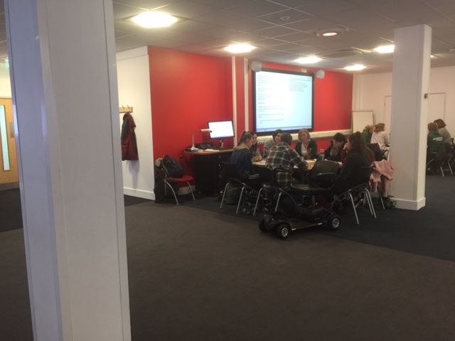

Session structure
The cohort is split into four small groups with approximately 8 students in each, and either a service user or carer present. Groups are encouraged to talk to the service user or carer about their personal stories. The individual is encouraged initially to introduce themselves, and to give a brief background, and the students are provided with basic starting questions to ask. Questions such as;
- How do you or does your husband manage the condition?
- Can you explain the type of MS you have and how this was diagnosed?
- What support have you found of most use?
- What advice would you give us as newly qualified health care professionals going into practice?
- Where do you find your information?
- Practicalities of day to day management
Students are encouraged to take brief notes, and to build up a picture of information they feel is relevant and to feed this back to the whole group. They are encouraged to include take home/into practice messages.

Following discussions, each group is asked to produce a poster of key points to then feedback to the whole group in mini feedback/presentation sessions (see below).

Following the poster presentations a small amount of time is allocated for themes of the afternoon to be discussed, and points to be summarised.

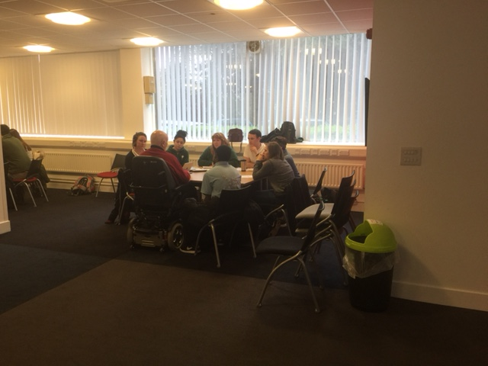

Evaluation of the first delivery of the session in April 2017
- The workshop worked extremely well, and feedback was generally very positive.
- Students and service users enjoyed the opportunity to get to know each other in more depth than would have been the case if students had been rotated to different individuals. They had time to ask questions that would not have been so easily done in practice.
- Poster presentations summarised key points, and enabled the students to hear themes raised on other tables, however students would have liked the opportunity to meet the other individuals also should time have allowed.
- The collaboration between the PIER partnership (Public Involvement in Education and Research) and students is invaluable in developing core skills for practice, and forging the foundations for practice with students.

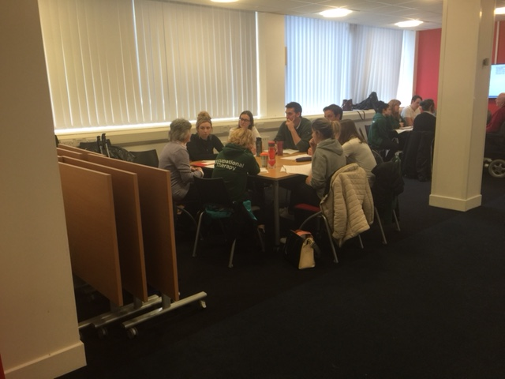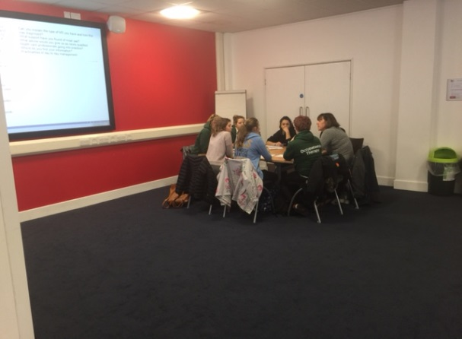

Student comments:
- Brilliant. Completely inspiring. So helpful – great insight to MS
- Thank you for coming to speak to us and sharing your personal experiences. Really useful this face to face contact time in the first year of OT to gain an understanding of the lives of individuals we may work with
- Thank you for your openness and honesty and for answering all of our questions
- Thank you very much for coming and sharing and talking to us. It is very helpful to hear from you as people who we will be working with in the future

Posters produced from the first delivery of this activity

